**UCID: 2024510001 BATCH: A NAME: Atharva Vasant Angre**

**EXPERIMENT NO: 04**

**EXPERIMENT TITLE:** To implement Knapsack Algorithm.

4.1 To Implement Knapsack Algorithm (0/1 Knapsack).

**Objective:**

1. To Implement Knapsack Algorithm (0/1 Knapsack).

**Program code:** -

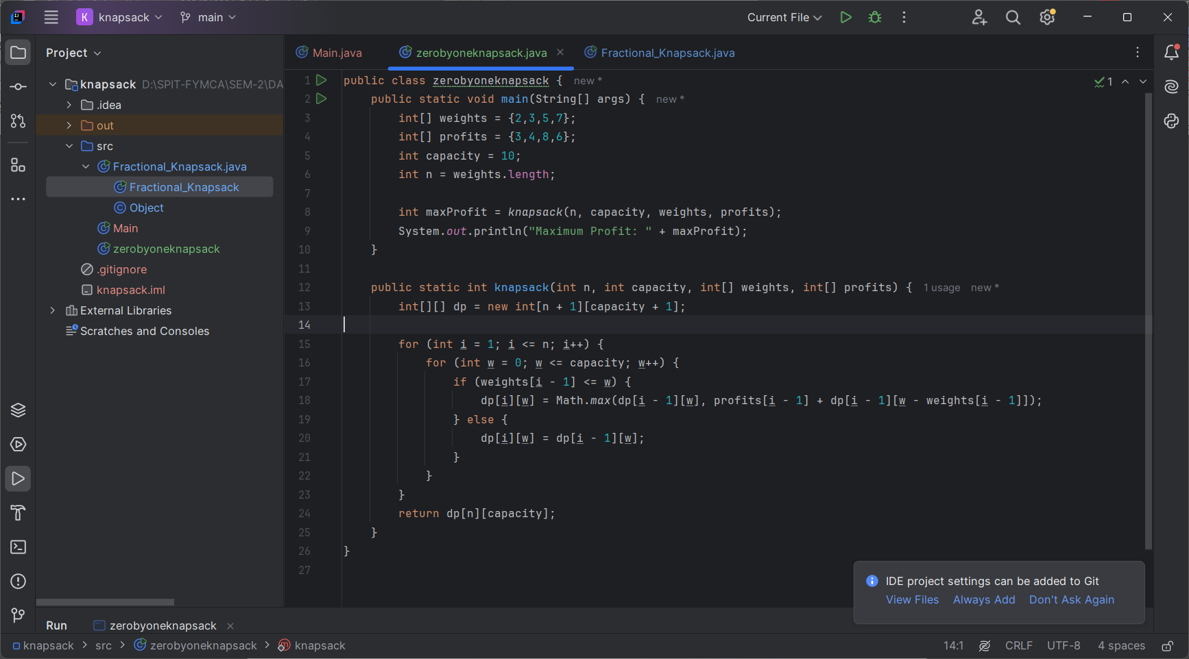 0/1 Knapsack

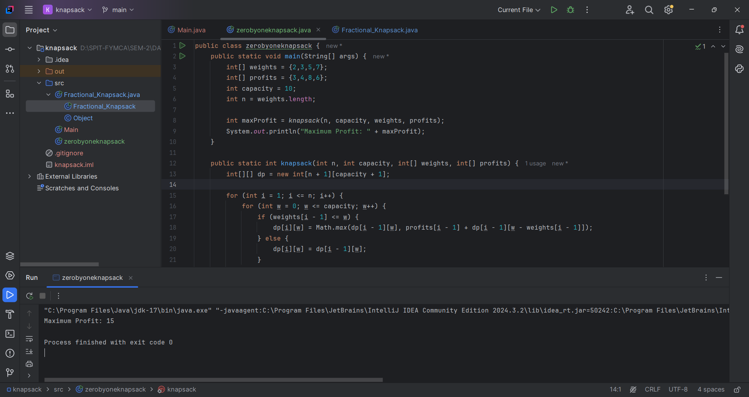**Output:**

**Conclusion:**

The 0/1 Knapsack Algorithm helps in selecting items to maximize profit while keeping the total weight within the given capacity. It uses Dynamic Programming to ensure the best selection by considering each item’s weight and profit. This method guarantees an optimal solution but requires extra space. Overall, it is an efficient and widely used approach for solving resource allocation problems.